

**University of Asia pacific**

***Department of Computer Science & Engineering***

Course code: cse-322.

Course title: Database Systems Lab

Sec: A (ii).

Project name: medical college database management system.

Date of Submission date: 18.09.2018

**Submitted by** **submitted to**

REg no. ; 16101031, 16101032, md. Nadeem ahmed

16101044. Assistant professor

University of Asia pacific

|  |  |
| --- | --- |
|  | **MEDICAL COLLEGE DATABASE**  **MANAGEMENT SYSTEM** |
|  |  |

**SUBMITTED BY:-**

|  |  |  |
| --- | --- | --- |
|  |  |  |
| **Md. Aminul Islam**  **ID: 16101031** | **Zarif Khan mojlish**  **ID: 16101032** | **Md. Al-amin Khan Riad**  **ID: 16101044** |

Table of the content

Page

1. About the project …………………………………………………………4
2. E-r diagram ……………………….…………………………………………... 5
3. Schema diagram ………………………………….………………………... 6
4. Queries & screen shots …………………….………………………… 7
5. Appendix a ……………………………………………………………………. 19
6. Appendix B ………………………...…………………………………………. 21

**About the Project:**

A Medical College started its journey in 1999-2000 and with 50 students but now there 200 students. Every year 50 students get allow for admission. Students have ID, name and the total credit they have completed. These students get admitted department-wise. Each department has name, building, budget. There are many courses under every department and courses have ID, title and credit. Students take courses where each course taught by a doctor. Every course is taken by many students. One student can take many courses and similarly, one doctor can teach many courses. All students and doctors must have a department and those departments that are included in this medical college department. Students and doctors also must have taken course year and taught course year respectively.

Our medical college is also a reputed hospital. This medical has some ward. Ward has ward no, category and building where its situated. Under these wards there are several beds and each bed for a single patient. Everyday there are many patients gets admitted and get proper treatment also. Every patient has ID, name, disease, bed no and assign doctor that must have every patient. Though every patient has one assign doctor but every single doctor has many patients. Each patient has some bills where bill no and amount are stored.

In this medical college, there is also a well-organized library. In this library there are many types of book where books have ID, name, category, publication, price. Students can issue book and every student can issue maximum two books at a time. They must return that within two weeks. A librarian can send message to a student for returning book or any other purpose. This messages must have date and a librarian has ID, name, designation and cell.

**E-R Diagram:**

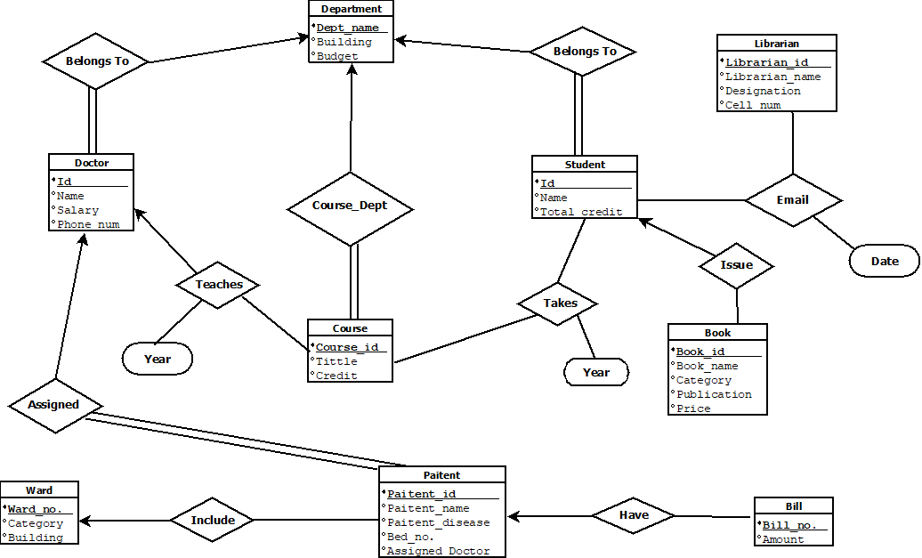

**Schema Diagram:**

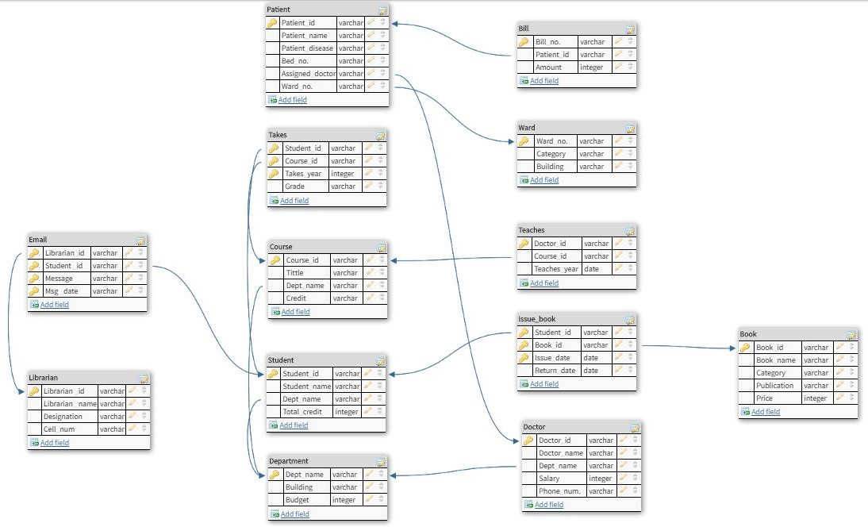

**Queries & Screen Shots:**

**Hospital Part**

1. Find the ward no of all patient without duplicates.

select distinct ward_no from Ward

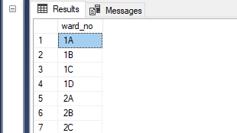

1. Find all patients in 1A no ward.

select Patient_name from Patient where Ward_no='1A';

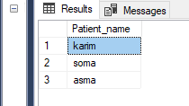

1. Sum of total bill of a patient.

select sum(Amount) from Bill;

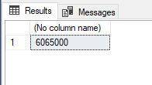

1. Find the total number of doctors whose assigned for patient in the “702”no ward.

select count(Assigned_doctor) from Patient where Ward_no='1A';

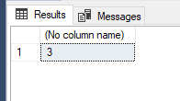

1. List all ward no along with the number of bed no in each ward.

select ward_no,bed_no from Patient;

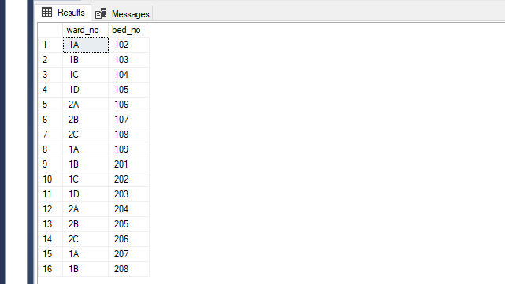

1. Find the total number of patient of “1A” no ward.

select count(distinct Patient_id) from Patient where Ward_no='1A';

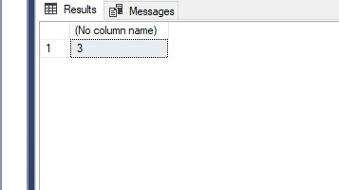

1. Find all ward no of burn category.

select all ward_no from Ward where Category='burn unit';

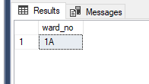

**College Part**

1. Find department name, building, budget/12 as monthly budget.

select Dept_name,Building,Budget/12 from Department;

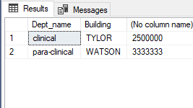

1. Find all students in clinical department with total credit>80

select stu_name from student where Dept_name ='clinical' and Total_credit>40;

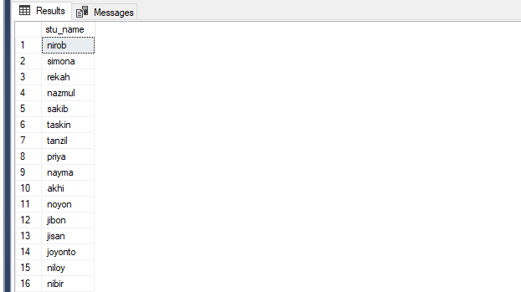

1. Find the names of all doctors who have a higher salary than some doctors in clinical department

Select distinct D.Doc_name from Doctor as D,Doctor as S where D.Salary>S.Salary and S.Dept_name = 'clinical';

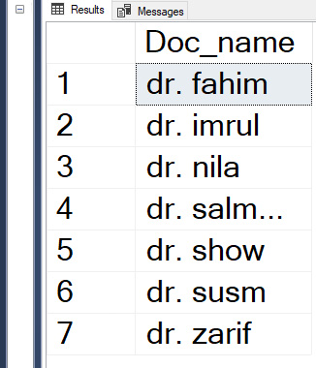

1. Find the names of all doctors with salary between 90000 and 100000.

select doc_name from Doctor where Salary between 90000 and 100000;

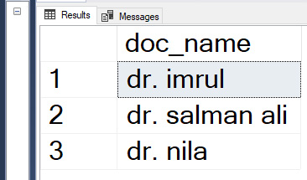

1. Find courses that teaches by doctors in 2011 or in 2012. (do this by union)

(select course_id from Teaches where Teaches_year = 2017) union (select course_id from Teaches where Teaches_year = 2018);

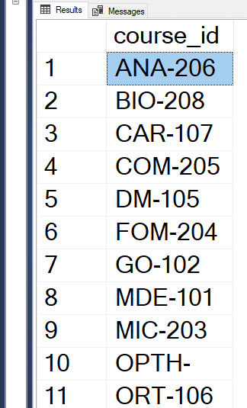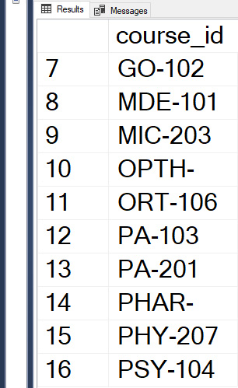

1. Find courses that teaches by doctors in 2009 and in 2010. (do this by intersect)

(select course_id from Teaches where Teaches_year = 2017) intersect (select course_id from Teaches where Teaches_year = 2018);

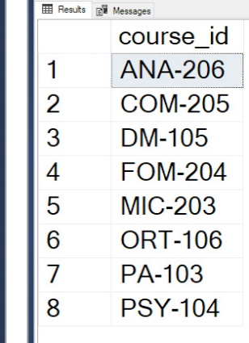

1. Find courses that takes by students in 2009 but not in 2018.(using except)

(select course_id from Teaches where Teaches_year = 2017) except (select course_id from Teaches where Teaches_year = 2018);

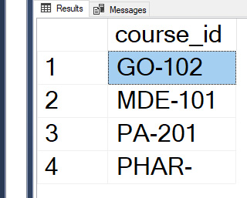

1. Find the salaries of all doctors that are less than the largest salary.

select distinct T.salary from Doctor as T, Doctor as S where T.Salary<S.Salary;

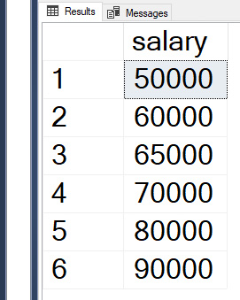

1. Find all the salaries of all doctors.

Select distinct salary from Doctor;

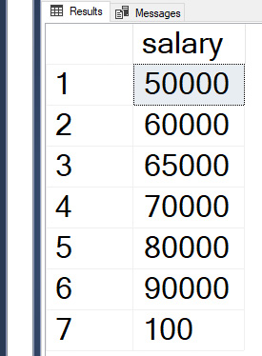

1. Find the maximum salary of doctors.

select max(salary)as Max_salary from Doctor;

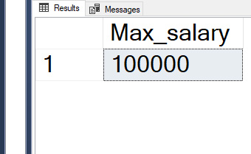

1. Find names of doctor with salary greater than that of some (at least one) doctor in the non-clinical department.

select distinct T.Doc_name from Doctor as T, Doctor as S where T.Salary>S.Salary and S.Dept_name = 'para-clinical';

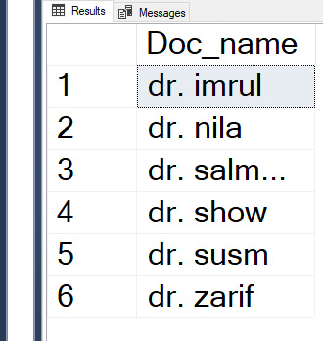

**Library Part**

1. Names and average prices of all categories whose average price is greater than 360

select Category, avg (Price)

from Book

group by Category

having avg (Price) > 360;

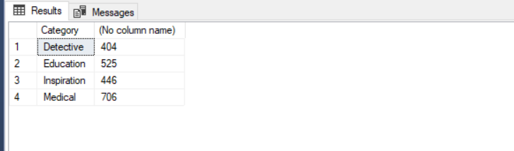

1. Average price of books in each category.

select Category, avg (Price) as avg_price

from Book

group by Category;

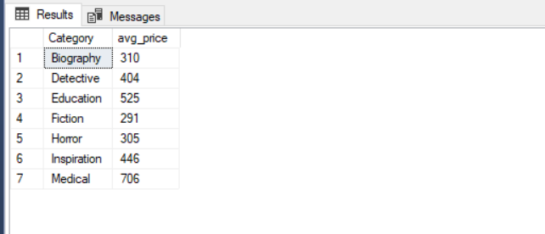

1. Total number of Issue books by students.

select count (*)

from Issue_book;

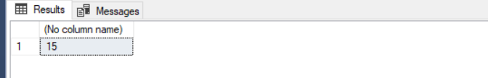

1. Total number of students who issued the books in the year of 2018.

select count(distinct Student_id)

from Issue_book

where (select Year(Issue_date)) = '2018';

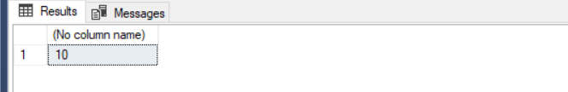

1. Average price of book in the DYD publication.

select avg (price)

from Book

where Publication= 'DYD';

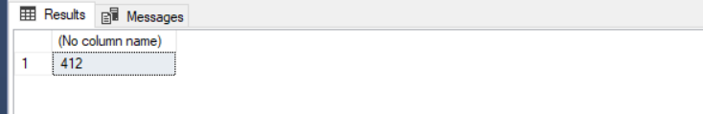

1. Minimum price of book.

select min (price)

from Book;

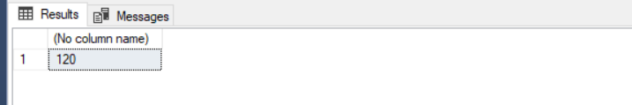

1. Students whose are not return their books.

select Student_id_

from Issue_book_

where Return_date is null;

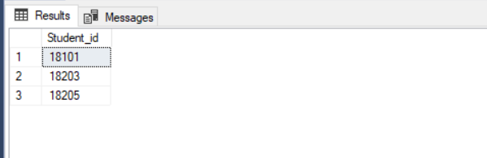

1. Maximum price of books in detective category.

select max (price)

from Book

where Category='detective';

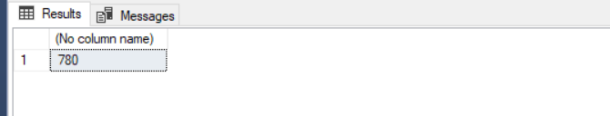

1. List in descending alphabetic order the names of all librarian.

select distinct Librarian_name

from Librarian

order by Librarian_name desc

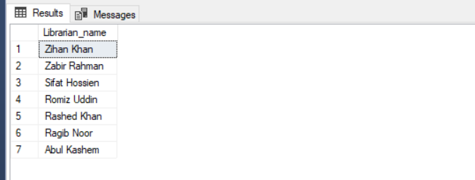

1. Names, contact number of all librarian who have sent some message and the message.

select Librarian_name,Cell_num,Message_

from Librarian, Email

where Librarian.Librarian_id=Email.Librarian_id;

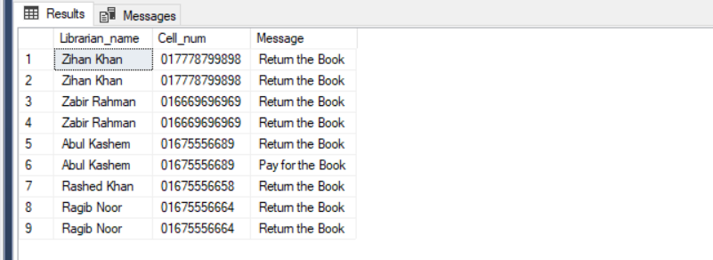

1. Names of all books where price is greater than the price of books in the fiction category.

select Book_name

from Book

where price > all (select Price

from Book

where Category = 'fiction');

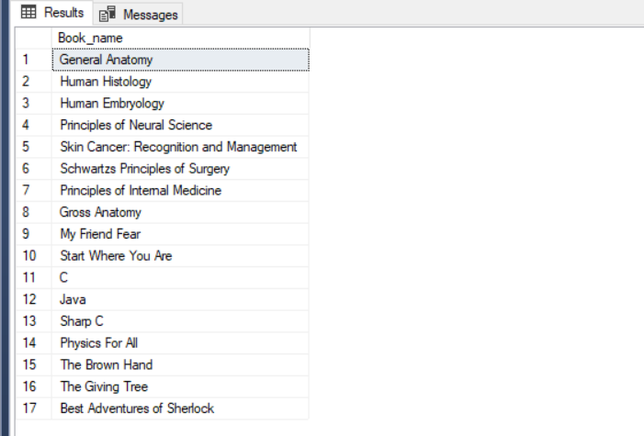

1. All categories where the total price of books is greater than the average of the total price at all categories.

with category_total (Category, value) as

(select Category, sum(Price)

from Book

group by Category),

category_total_avg(value) as

(select avg(value)

from category_total)

select Category

from category_total, category_total_avg

where category_total.value > category_total_avg.value;

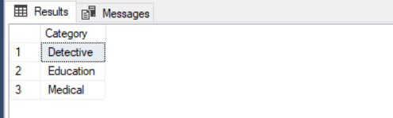

**Appendix A:**

create table Department(

Dept_name varchar(60),

Building varchar(60),

Budget int,

constraint pk_department primary key([Dept_name])

);

create table Librarian(

Librarian_id varchar(60),

Librarian_name varchar(60),

Designation varchar(60),

Cell_num varchar(60),

constraint pk_librarian primary key([Librarian_id])

);

create table Book(

Book_id varchar(60),

Book_name varchar(60),

Category varchar(60),

Publication varchar(60),

Price int,

constraint pk_book primary key([Book_id])

);

create table Ward(

Ward_no varchar(60),

Category varchar(60),

Building varchar(60),

constraint pk_ward primary key([Ward_no])

);

create table Doctor(

Doctor_id varchar(60),

Doc_name varchar(60),

Dept_name varchar(60),

Salary int,

Phone_num varchar(60),

constraint pk_doctor primary key([Doctor_id]),

constraint fk_doctor foreign key([Dept_name]) references Department(Dept_name)

);

create table Student(

Student_id varchar(60),

Stu_name varchar(60),

Dept_name varchar(60),

Total_credit float,

constraint pk_student primary key([Student_id]),

constraint fk_student foreign key([Dept_name]) references Department([Dept_name])

);

create table Course(

Course_id varchar(60),

Tittle varchar(60),

Dept_name varchar(60),

Credit float,

constraint pk_course primary key([Course_id]),

constraint fk_course foreign key([Dept_name]) references Department([Dept_name])

);

create table Takes(

Student_id varchar(60),

Course_id varchar(60),

Takes_year varchar(60),

Grade varchar(60),

constraint pk_takes primary key([Student_id],[Course_id],[Takes_year]),

constraint fk_takes1 foreign key([Student_id]) references Student,

constraint fk_takes2 foreign key([Course_id]) references Course

);

create table Teaches(

Doctor_id varchar(60),

Course_id varchar(60),

Teaches_year varchar(60),

constraint pk_teaches primary key([Doctor_id],[Course_id],[Teaches_year]),

constraint fk_teaches1 foreign key([Doctor_id]) references Doctor,

constraint fk_teaches2 foreign key([Course_id]) references Course

);

create table Issue_book(

Student_id varchar(60),

Book_id varchar(60),

Issue_date date,

Return_date date,

constraint pk_ibook primary key([Student_id],[Book_id],[Issue_date]),

constraint fk_ibook1 foreign key([Student_id]) references Student,

constraint fk_ibook2 foreign key([Book_id]) references Book

);

create table Email(

Librarian_id varchar(60),

Student_id varchar(60),

Message varchar(600),

Msg_date date,

constraint pk_email primary key([Librarian_id],[Student_id],[Message],[Msg_date]),

constraint fk_email1 foreign key([Student_id]) references Student,

constraint fk_email2 foreign key([Librarian_id]) references Librarian

);

create table Patient(

Patient_id varchar(60),

Patient_name varchar(60),

Patient_disease varchar(60),

Bed_no varchar(60),

Assigned_doctor varchar(60),

Ward_no varchar(60),

constraint pk_patient primary key([Patient_id]),

constraint fk_patient foreign key([Ward_no]) references Ward(Ward_no),

constraint fk_patient2 foreign key([Assigned_doctor]) references Doctor(Doctor_id)

);

create table Bill (

Bill_no varchar(60),

Patient_id varchar(60),

Amount int,

constraint pk_bill primary key([Bill_no]),

constraint fk_bill foreign key([Patient_id]) references Patient

);

**Appendix B:**

insert into Department values('clinical','TYLOR',30000000),

('para-clinical','WATSON',40000000);

insert into Librarian values('666','Romiz Uddin','Head','01848898999'),

('667','Sifat Hossien','Assistant Head','019965665667'),

('668','Zihan Khan','Assistant','017778799898'),

('669','Zabir Rahman','Assistant','016669696969'),

('670','Abul Kashem','Assistant','01675556689'),

('671','Rashed Khan','Assistant','01675556658'),

('672','Ragib Noor','Assistant','01675556664');

insert into Book values('760','General Anatomy','Medical','GLG',750),

('761','Physiology','Medical','CNC',450),

('762','Biochemistry','Medical','DLD',350),

('763','Human Histology','Medical','NLN',700),

('764','Human Embryology','Medical','KLL',900),

('765','Principles of Neural Science','Medical','LKL',800),

('766','Skin Cancer: Recognition and Management','Medical','NSN',600),

('767','Schwartzs Principles of Surgery','Medical','NPN',1000),

('768','Principles of Internal Medicine','Medical','SLS',950),

('769','Gross Anatomy','Medical','DYD',560),

('770','Blackberry Winter','Biography','GLG',200),

('771','Valentino','Biography','CNC',250),

('772','Swans','Biography','GLG',200),

('773','The Edge of Memory','Biography','DLD',400),

('774','Sea Prayer','Biography','NLN',500),

('775','War Like a Local','Fiction','GLG','200'),

('776','THE ROGER BROOK SERIES STARTER','Fiction','GLG',350),

('777','THE SWORD OF FATE','Fiction','DLD',300),

('778','UNCHARTED SEAS','Fiction','NLN',200),

('779','Holy Terror','Horror','KLL',350),

('780','Trauma','Horror','LKL',400),

('781','House of Bones','Horror','LKL',500),

('782','The Satanist','Horror','KLL',300),

('783','Made out of Stars','Inspiration','NSN',200),

('784','My Friend Fear','Inspiration','SLS',600),

('785','Start Where You Are','Inspiration','NPN',600),

('786','Coders','Education','NSN',200),

('787','Learn C','Education','CNC',200),

('788','C','Education','NPN',700),

('789','Java','Education','DLD',700),

('790','Sharp C','Education','NSN',800),

('791','Physics For All','Education','SLS',900),

('792','Vector','Education','DYD',500),

('793','Database','Education','GLG',200),

('794','Hound of the Vaskerbills','Detective','DYD',380),

('795','Adventure of the Empty House','Detective','DYD',250),

('796','Scandal in Bohemia','Detective','SLS',210),

('797','Chader Pahar','Fiction','DYD',520),

('798','The Secret Garden','Inspiration','NPN',330),

('799','Shikar','Horror','LKL',120),

('800','Life Without Limits','Inspiration','NSN',280),

('801','The Final Problem','Fiction','KLL',180),

('802','Satyanneshi Byomkesh','Detective','DYD',420),

('803','Hattyapuri','Detective','DYD',260),

('804','The Brown Hand','Detective','CNC',780),

('805','Sheyal Debota Rahassha','Detective','CNC',380),

('806','Gangtok e Gondogol','Detective','KLL',380),

('807','The Giving Tree','Inspiration','NLN',670),

('808','Best Adventures of Sherlock','Detective','DLD',580),

('809','Zombies','Horror','CNC',160);

insert into Ward values ('1A','burn unit','RH'),

('1B','coronary care unit','Packard'),

('1C','emergency unit','Painter'),

('1D','acute medical unit ','Packard'),

('2A','geriatric intensive- care unit','Painter'),

('2B','neonatal intensive care unit ','RH'),

('2C','pediatric intensive care unit ','Packard');

insert into Doctor values('031','dr. abdullah','clinical',50000,'01521207638'),

('032','dr. zarif','clinical',80000,'01944149959'),

('033','dr. imrul','clinical',90000,'01712369871'),

('034','dr. salman ali','clinical',100000,'01676600767'),

('035','dr. fahim','para-clinical',60000,'0176669990'),

('036','dr. showrav','para-clinical',70000,'01199788779'),

('037','dr. susmita','para-clinical',65000,'01981718789'),

('038','dr. nila','para-clinical',100000,'0174568928');

insert into Student values('18101','ahmed zamil','clinical',20.5),

('18102','zafar ali','clinical',20.5),

('18103','soma','clinical',24.0),

('18104','Hatem Tai','clinical',20.5),

('18105','Nyeem Azgar','clinical',21.5),

('18106','Shorif miya','clinical',22.5),

('18107','sophiya','clinical',23.5),

('18108','Hossain Sordar','clinical',20.5),

('18109','nirob','clinical',45.5),

('18110','simona','clinical',46.5),

('18111','rekah','clinical',48.5),

('18112','nazmul','clinical',49.0),

('18113','sakib','clinical',46.0),

('18114','taskin','clinical',45.5),

('18115','tanzil','clinical',46.5),

('18116','priya','clinical',46.5),

('18117','nayma','clinical',72.5),

('18118','akhi','clinical',74.0),

('18119','noyon','clinical',73.5),

('18120','jibon','clinical',70.5),

('18121','jisan','clinical',72.5),

('18122','joyonto','clinical',74.0),

('18123','niloy','clinical',72.5),

('18124','nibir','clinical',73.5),

('18201','antor','para-clinical',21.0),

('18202','labib','para-clinical',22.5),

('18203','hiron','para-clinical',21.5),

('18204','minhaz','para-clinical',24.5),

('18205','nakib','para-clinical',21.5),

('18206','sondip','para-clinical',21.5),

('18207','mow','para-clinical',21.5),

('18208','kona','para-clinical',21.5),

('18209','shakil','para-clinical',46.5),

('18210','shawon','para-clinical',46.5),

('18211','rony','para-clinical',46.5),

('18212','shojol','para-clinical',47.5),

('18213','rubel','para-clinical',48.5),

('18214','munna','para-clinical',49.5),

('18215','anik','para-clinical',49.5),

('18216','shojib','para-clinical',47.5),

('18217','hasif','para-clinical',71.5),

('18218','shorif','para-clinical',71.5),

('18219','momin','para-clinical',71.5),

('18220','arman','para-clinical',72.5),

('18221','hanif','para-clinical',73.5),

('18222','altaf','para-clinical',74.0),

('18223','bokul','para-clinical',74.5),

('18224','kotha','para-clinical',72.5);

insert into Course values('MDE-101','medicine','clinical',4.0),

('GO-102','gynea & obs','clinical',4.5),

('PA-103','paediatrics','clinical',4.0),

('PSY-104','psychiatry','clinical',4.0),

('DM-105','dermatology','clinical',4.5),

('ORT-106','orthopedics','clinical',4.5),

('CAR-107','cardiology','clinical',4.5),

('OPTH-108','ophthalmology','clinical',4.0),

('PA-201','pathology','para-clinical',4.5),

('PHAR-202','pharmacology','para-clinical',4.5),

('MIC-203','microbiology','para-clinical',4.5),

('FOM-204','forensic medicine','para-clinical',4.5),

('COM-205','community medicine','para-clinical',4.0),

('ANA-206','anatomy','para-clinical',4.5),

('PHY-207','physiology','para-clinical',4.5),

('BIO-208','biochemistry','para-clinical',4.5);

insert into Takes values('18101','MDE-101','2017','A'),

('18102','GO-102','2017','A-'),

('18103','MDE-101','2017','B'),

('18104','GO-102','2017','B+'),

('18107','MDE-101','2017','C+'),

('18108','GO-102','2017','D'),

('18109','PA-103','2017','C+'),

('18110','PSY-104','2017','C-'),

('18113','PA-103','2017','B-'),

('18114','PSY-104','2017','A'),

('18115','PA-103','2017','A+'),

('18116','PSY-104','2017','A+'),

('18119','DM-105','2017','A-'),

('18120','ORT-106','2017','A'),

('18121','DM-105','2017','A'),

('18122','ORT-106','2017','B+'),

('18103','PA-103','2018','B-'),

('18104','PSY-104','2018','B'),

('18105','PA-103','2018','B'),

('18106','PSY-104','2018','B-'),

('18109','DM-105','2018','A-'),

('18110','ORT-106','2018','D'),

('18111','DM-105','2018','F'),

('18112','ORT-106','2018','F'),

('18115','DM-105','2018','A+'),

('18116','ORT-106','2018','C'),

('18117','CAR-107','2018','C-'),

('18118','OPTH-108','2018','D'),

('18121','CAR-107','2018','A'),

('18122','OPTH-108','2018','B'),

('18123','CAR-107','2018','A-'),

('18124','OPTH-108','2018','B-'),

('18203','PA-201','2017','B'),

('18204','PHAR-202','2017','A+'),

('18205','PA-201','2017','B+'),

('18206','PHAR-202','2017','A-'),

('18209','MIC-203','2017','B-'),

('18210','FOM-204','2017','D'),

('18211','MIC-203','2017','C'),

('18212','FOM-204','2017','A'),

('18215','MIC-203','2017','C+'),

('18216','FOM-204','2017','C-'),

('18217','COM-205','2017','A-'),

('18218','ANA-206','2017','B'),

('18221','COM-205','2017','D'),

('18222','ANA-206','2017','C-'),

('18223','COM-205','2017','A'),

('18224','ANA-206','2017','B-'),

('18201','MIC-203','2018','D'),

('18202','FOM-204','2018','C+'),

('18203','MIC-203','2018','C-'),

('18204','FOM-204','2018','A+'),

('18207','MIC-203','2018','A'),

('18208','FOM-204','2018','C+'),

('18209','COM-205','2018','A-'),

('18210','ANA-206','2018','B-'),

('18213','COM-205','2018','C'),

('18214','ANA-206','2018','C-'),

('18215','COM-205','2018','A'),

('18216','ANA-206','2018','B'),

('18219','PHY-207','2018','B+'),

('18220','BIO-208','2018','B-'),

('18221','PHY-207','2018','D'),

('18222','BIO-208','2018','C+');

insert into Teaches values('031','MDE-101','2017'),

('032','GO-102','2017'),

('033','PA-103','2017'),

('034','PSY-104','2017'),

('033','DM-105','2017'),

('034','ORT-106','2017'),

('031','CAR-107','2018'),

('032','OPTH-108','2018'),

('033','PA-103','2018'),

('034','PSY-104','2018'),

('033','DM-105','2018'),

('034','ORT-106','2018'),

('035','PA-201','2017'),

('036','PHAR-202','2017'),

('037','MIC-203','2017'),

('038','FOM-204','2017'),

('037','COM-205','2017'),

('038','ANA-206','2017'),

('035','PHY-207','2018'),

('036','BIO-208','2018'),

('037','MIC-203','2018'),

('038','FOM-204','2018'),

('037','COM-205','2018'),

('038','ANA-206','2018');

insert into Issue_book values('18107','760','2017-10-16','2017-10-26'),

('18109','760','2017-11-22','2017-12-05'),

('18107','783','2018-01-08','2018-01-26'),

('18106','795','2018-01-29','2018-02-05'),

('18203','763','2018-02-26',null),

('18108','768','2018-03-14','2018-03-22'),

('18115','765','2018-04-06','2018-05-02'),

('18212','801','2018-04-24','2018-05-16'),

('18104','770','2018-05-08','2018-05-28'),

('18101','786','2018-05-12','2018-05-21'),

('18106','772','2018-06-15','2018-06-28'),

('18121','764','2018-06-22','2018-07-10'),

('18108','798','2018-07-02','2018-07-22'),

('18205','806','2018-07-19',null),

('18101','769','2018-08-03',null);

insert into Email values('669','18107','Return the Book','2018-01-22'),

('668','18203','Return the Book','2018-03-10'),

('670','18203','Pay for the Book','2018-03-24'),

('671','18115','Return the Book','2018-04-20'),

('672','18212','Return the Book','2018-05-08'),

('670','18104','Return the Book','2018-05-22'),

('668','18121','Return the Book','2018-07-06'),

('672','18108','Return the Book','2018-07-16'),

('669','18205','Return the Book','2018-08-03');

insert into Patient values('1610','karim','pneumonia','102','031','1A'),

('1611','rahim','Blood Pressure','103','032','1B'),

('1612','jamil','skin','104','033','1C'),

('1613','sohel','fever','105','034','1D'),

('1614','mita','diabetes','106','035','2A'),

('1615','mira','overweight','107','036','2B'),

('1616','mona','stroke','108','037','2C'),

('1617','soma','influenza','109','038','1A'),

('1618','noman','foot & mouth','201','031','1B'),

('1619','silviya','fascioliasis','202','032','1C'),

('1620','abir','malaria','203','033','1D'),

('1621','akib','dengue','204','034','2A'),

('1622','asif','typhoid','205','035','2B'),

('1623','sorna','viral fevers','206','036','2C'),

('1624','asma','cholera','207','037','1A'),

('1625','payel','hepatitis B','208','038','1B');

insert into Bill values('16101031','1610',20000),

('16101032','1611',30000),

('16101033','1612',100000),

('16101034','1613',1200000),

('16101035','1614',200000),

('16101036','1615',2200000),

('16101037','1616',400000),

('16101038','1617',500000),

('16101039','1618',60000),

('16101040','1619',70000),

('16101041','1620',80000),

('16101042','1621',90000),

('16101043','1622',550000),

('16101044','1623',110000),

('16101045','1624',330000),

('16101046','1625',40000),

('16101047','1621',10000),

('16101048','1614',20000),

('16101049','1610',30000),

('16101050','1610',25000);